Patients

\* `PatientID` (Primary Key)

\* `FirstName`

\* `LastName`

\* `Gender` (Check: 'M' or 'F')

\* `DateOfBirth`

\* `PhoneNumber` (Must be unique)

\* `Email` (Can be NULL)

Doctors

\* `DoctorID` (Primary Key)

\* `FirstName`

\* `LastName`

\* `Specialization` (e.g., 'Cardiology', 'Neurology')

\* `PhoneNumber` (Unique, NOT Null)

Appointments

\* `AppointmentID` (Primary Key)

\* `PatientID` (Foreign Key → Patients)

\* `DoctorID` (Foreign Key → Doctors)

\* `AppointmentDate`

\* `Diagnosis` (Can be NULL)

\* `Fees` (Must be greater than 0)

1. Create the `Patients`, `Doctors`, and `Appointments` tables with proper constraints (PK, FK, NOT NULL, UNIQUE, CHECK).

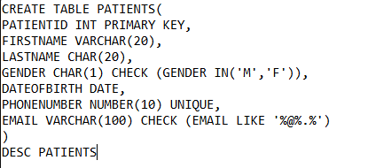

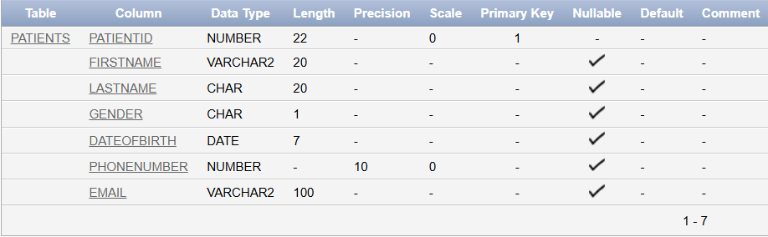

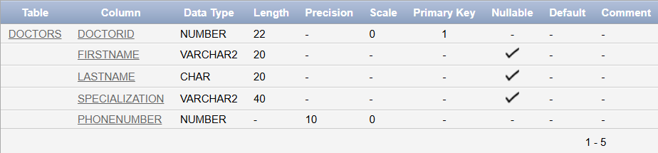

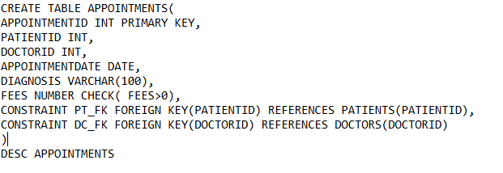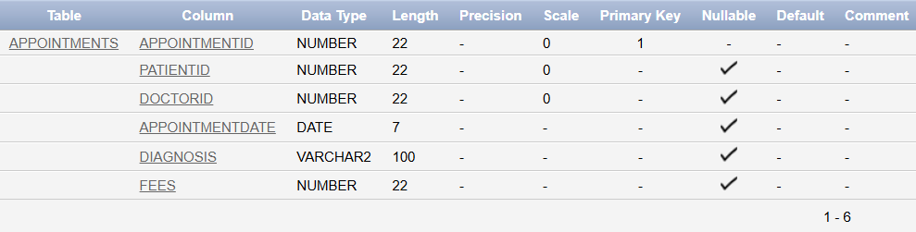

2. Add a `BloodGroup` column to the `Patients` table (`VARCHAR2(3)`).

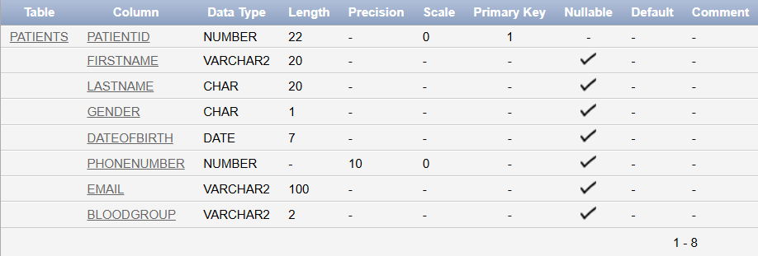

3. Modify the `Diagnosis` column in `Appointments` to increase its length to 200 characters.

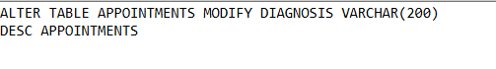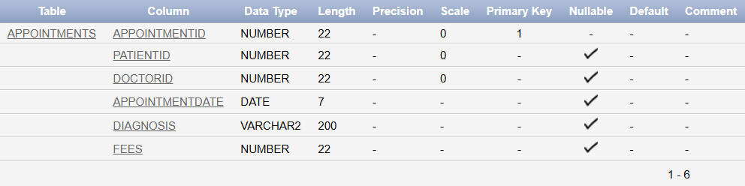

4. Insert 5 patients, 3 doctors, and at least 6 appointments.

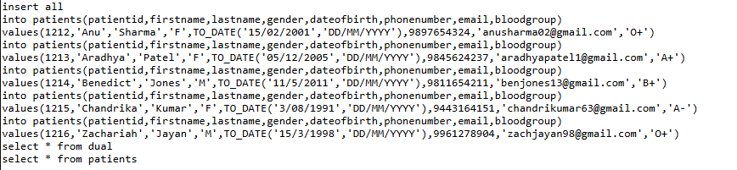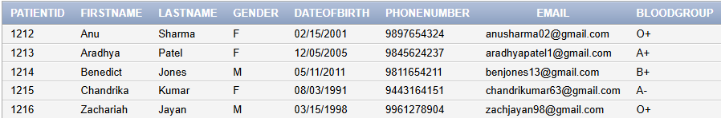

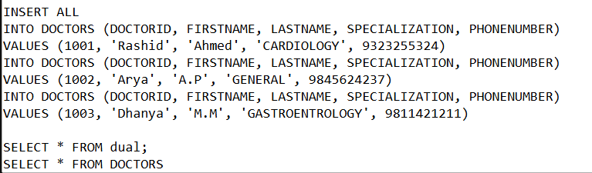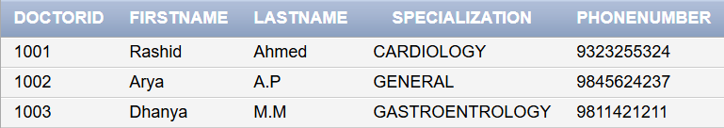

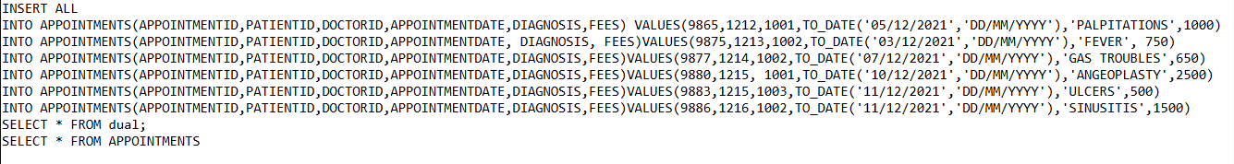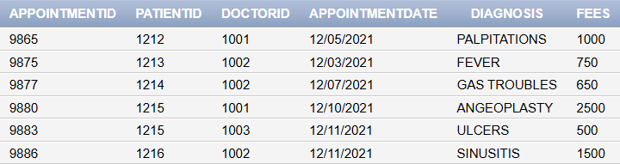

5. Update the `Fees` of a specific appointment to include a 15% increase.

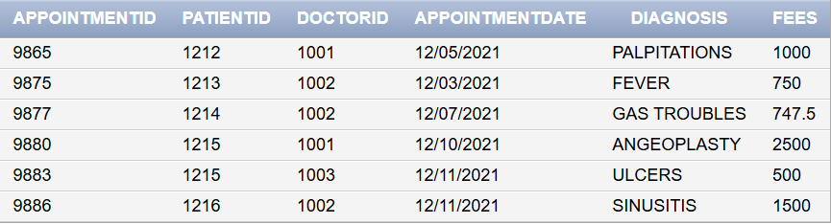

6. Delete a patient and all their appointments.

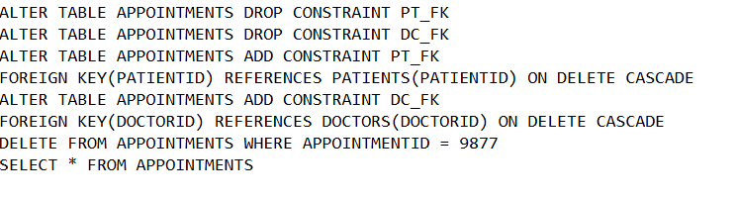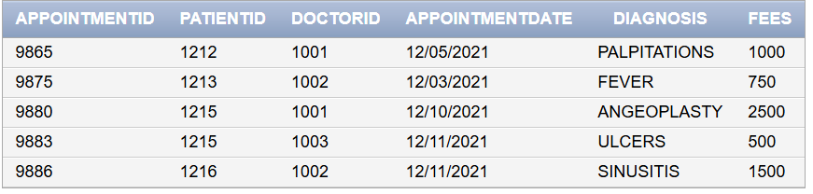

7. List all patients sorted by `LastName`.

8. Show all \*distinct specializations\* from the doctors.

9. Find patients born before 2000.

10. List appointments with fees greater than 500

11. Find all doctors whose specialization starts with 'Neuro'.

12. Display all patients with NULL email addresses.

13. Retrieve appointments with NULL diagnosis.

14. Show all appointment fees and their values after adding 10% tax.

15. List appointments where the fee is between 300 and 700.

16. Show patients who are not female.

17. Display patients’ \*age\* calculated from `DateOfBirth`.